# Lab Week 1.2 : indices and Buffers

# Follow Along : Indices

* Follow along in class to see how to
  + Create and fill an array of VertexPositionColor
  + Create and fill and array of indices (short[])
  + Draw our vertex array using GraphicsDevice.DrawUserIndexedPrimitives

# Exercise 1 : Building a Pyramid

* Using a Triangle List
  + Declare the vertices for a pyramid
  + Start with 9 vertices
* Optimize the pyramid
  + Update the pyramid code to now use indices

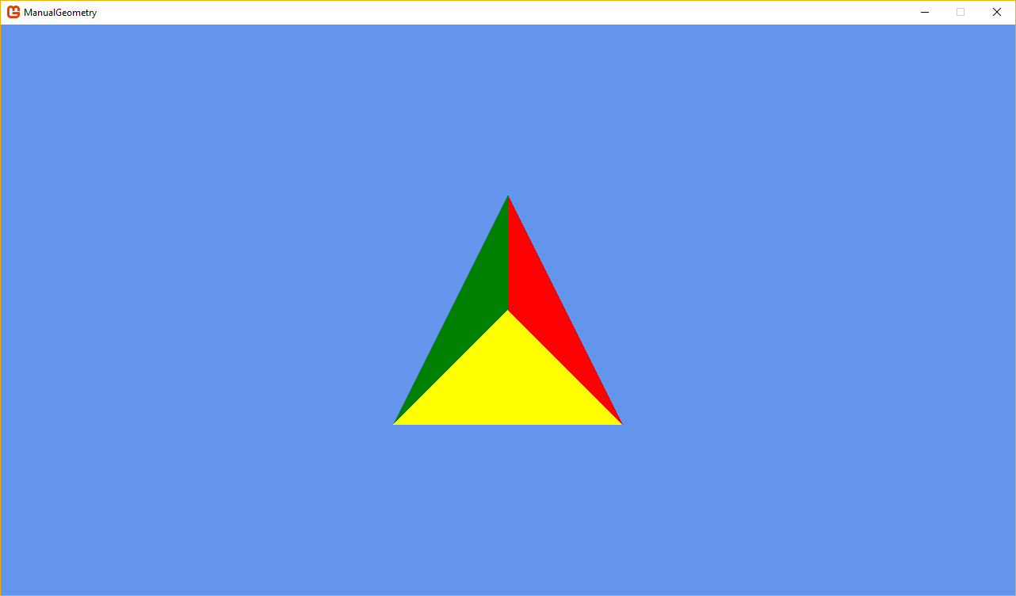

Figure Pyramid has been rotated by 90 degrees on the X Axis

# Exercise 2 : Building a Cube

* Using a Triangle List
  + Declare the vertices for a cube
* Optimize the cube
  + Update the cube code to now use indices